FortiGate Documentation — HQ (Forti 1) and BR (Forti 2)
1. Introduction
This document provides separate and detailed documentation for:
- FortiGate 1 (HQ)
- FortiGate 2 (BR)
Both devices use the same VLAN structure, firewall policies, and security profiles to maintain standardization and consistent security across sites.
2. FortiGate 1 — HQ Configuration
2.1 VLANs (HQ)
- IT – VLAN 10 – 192.168.10.0/24
- HR – VLAN 20 – 192.168.20.0/24
- Finance – VLAN 30 – 192.168.30.0/24
- Management – VLAN 40 – 192.168.40.0/24
- Sales – VLAN 50 – 192.168.50.0/24
- Servers – VLAN 60 – 192.168.60.0/24
2.2 Firewall Policies (HQ)
Firewall Policies Implemented
The following firewall policies were created and configured on this FortiGate device.
Each policy includes a screenshot for reference, showing the exact configuration applied on the firewall.

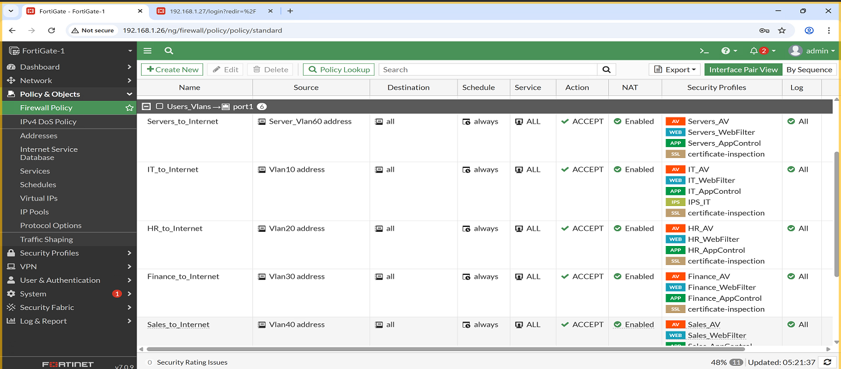
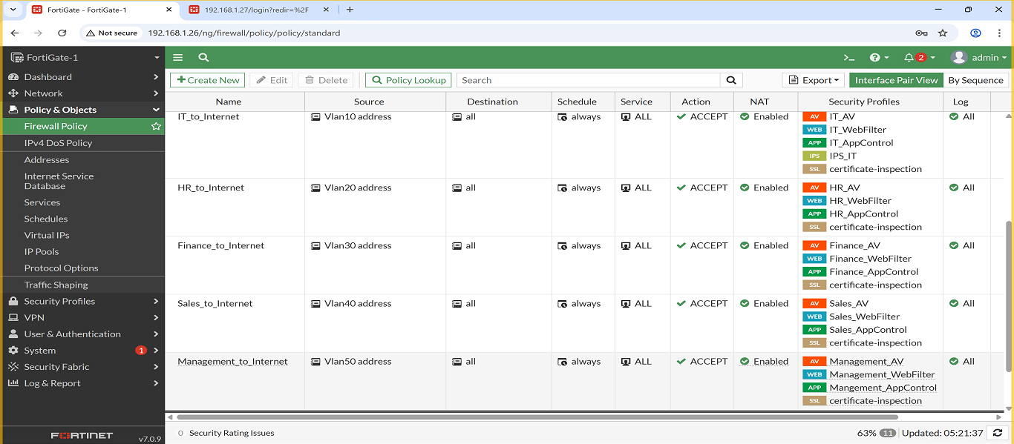

1. Policy: IT → Internet
- Description: Allows IT VLAN access to the internet, and applies the following security profiles: Web Filter, Antivirus, Application Control, and IPS.
- Screenshot:
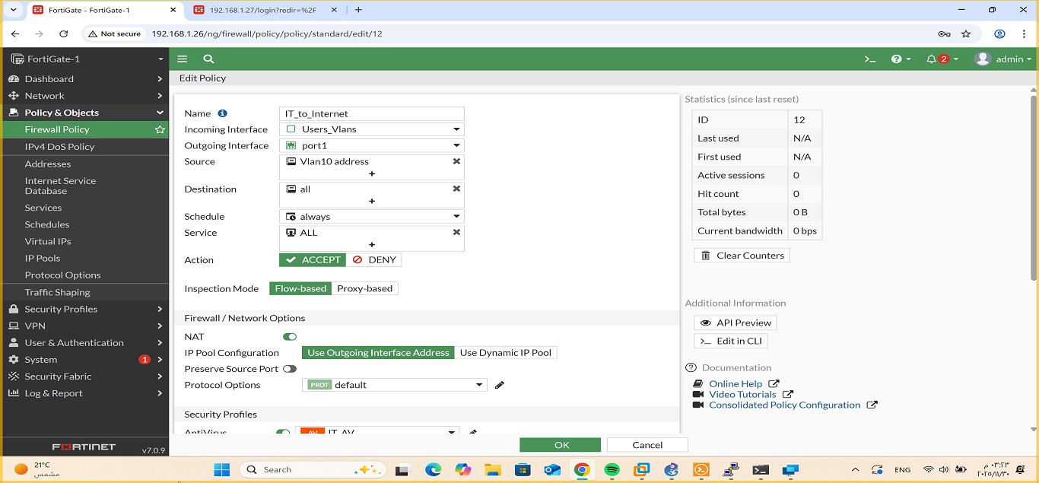
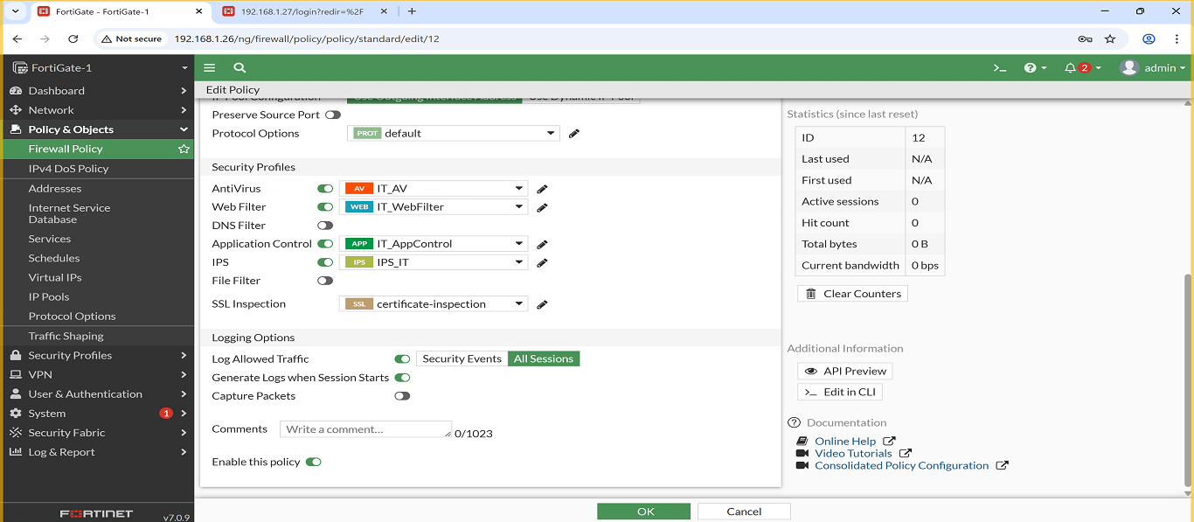

2. Policy: HR → Internet
- Description: Allows HR VLAN access to the internet, and applies the following security profiles: Web Filter, Antivirus and Application Control.
- Screenshot:
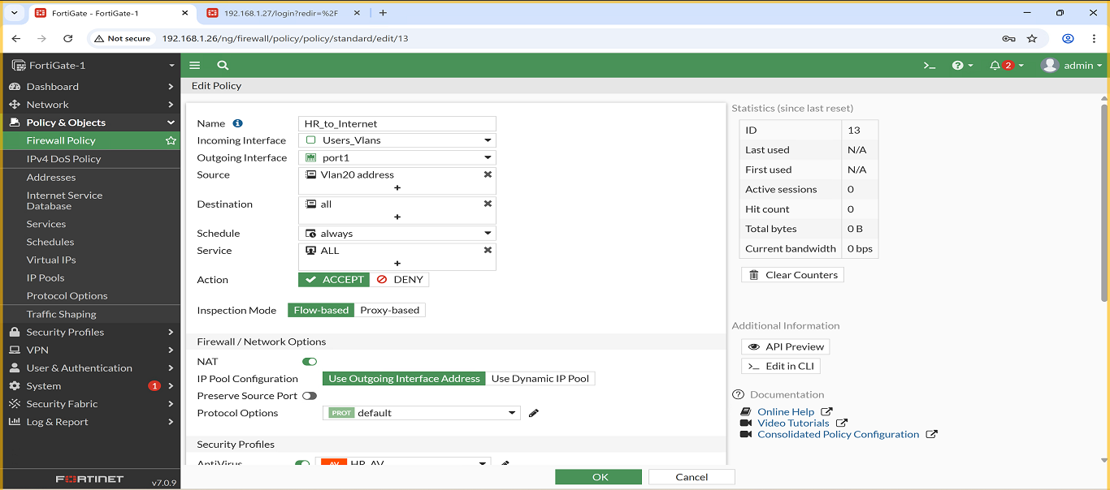
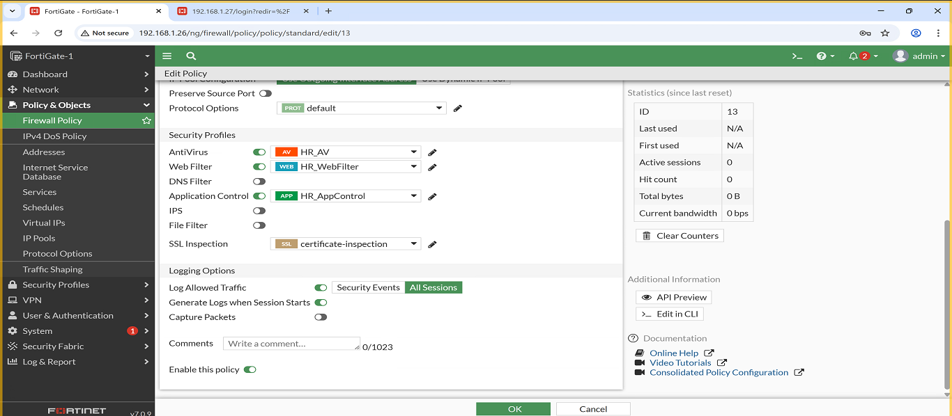
3. Policy: Finance → Internet
Description: Allows Finance VLAN access to the internet, and applies the following security profiles: Web Filter, Antivirus and Application Control.
- Screenshot:
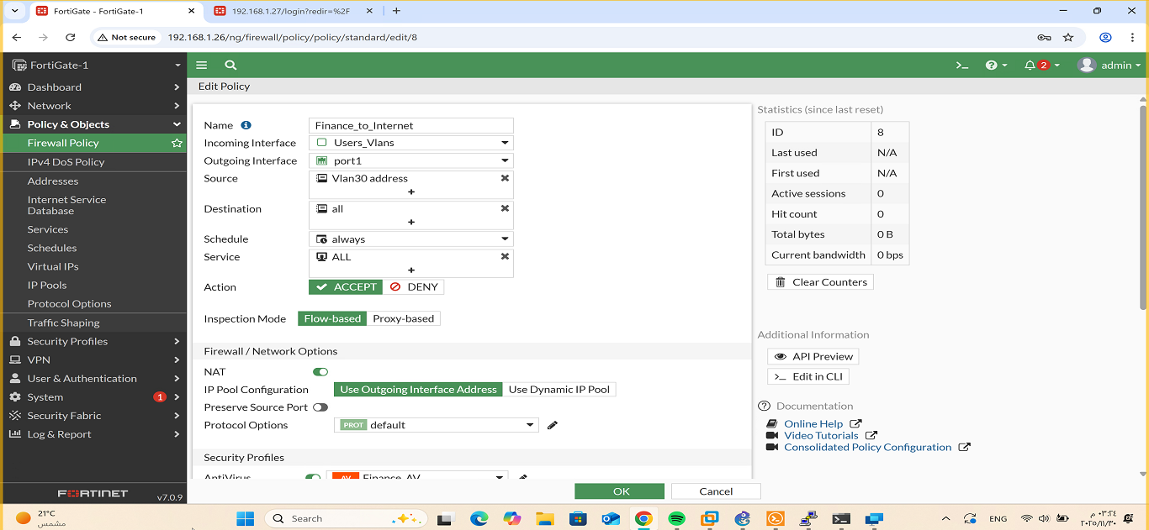
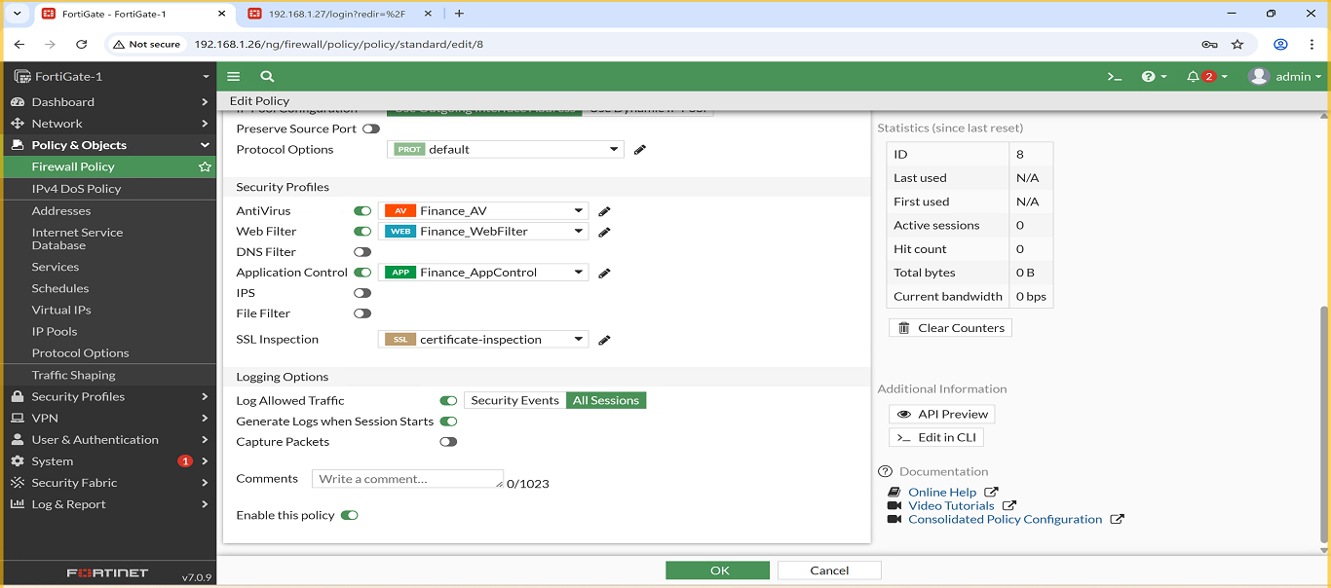
4. Policy: Management → Internet
- Description: Allows Management VLAN access to the internet, and applies the following security profiles: Web Filter, Antivirus and Application Control.
- Screenshot:
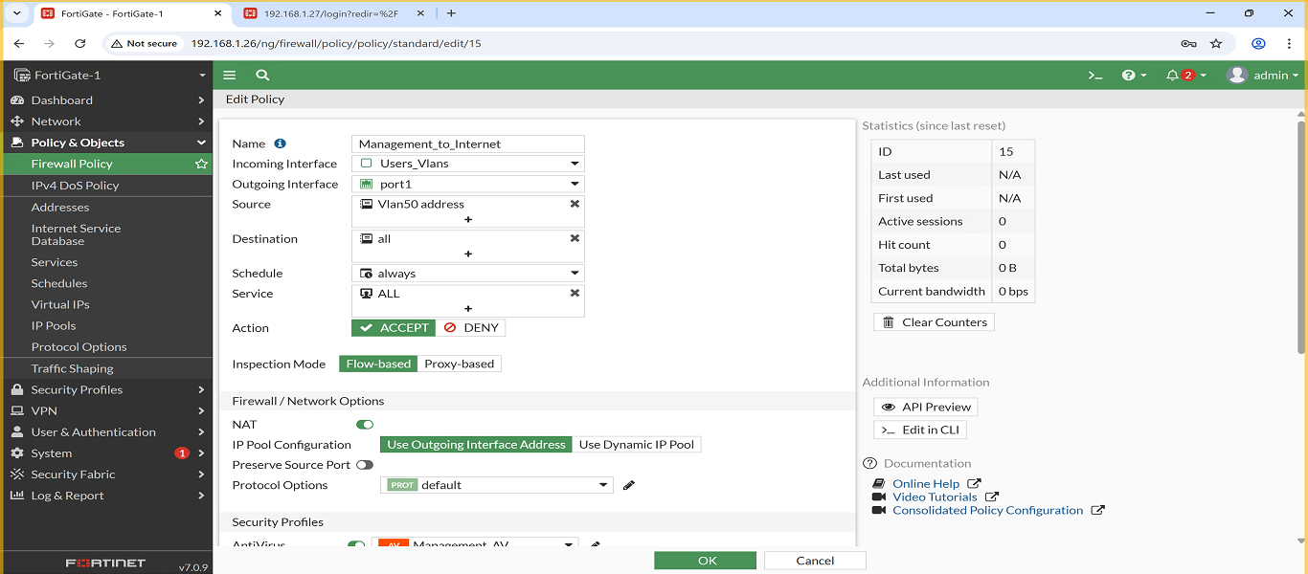
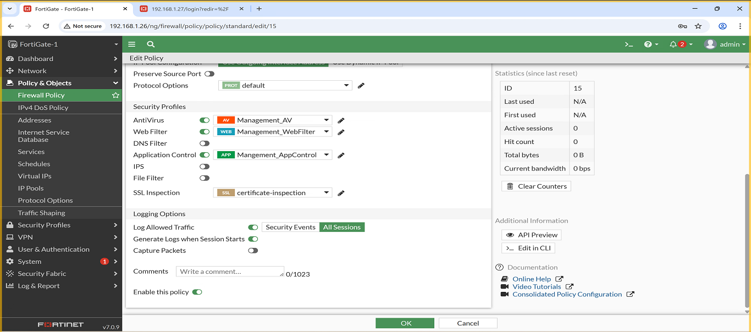
5. Policy: Sales → Internet
- Description: Allows Sales VLAN access to the internet, and applies the following security profiles: Web Filter, Antivirus and Application Control.
- Screenshot:
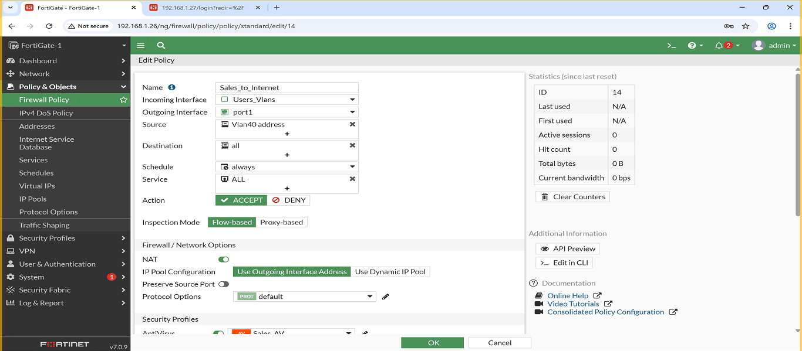
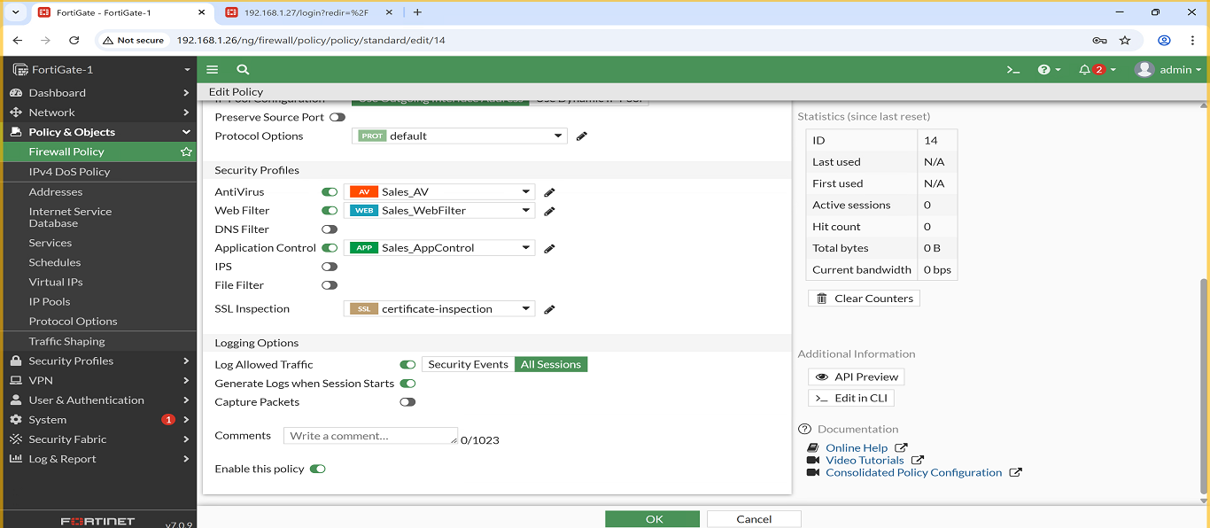
6. Policy: Servers → Internet
- Description: Allows Servers VLAN access to the internet, and applies the following security profiles: Web Filter, Antivirus and Application Control.
- Screenshot:

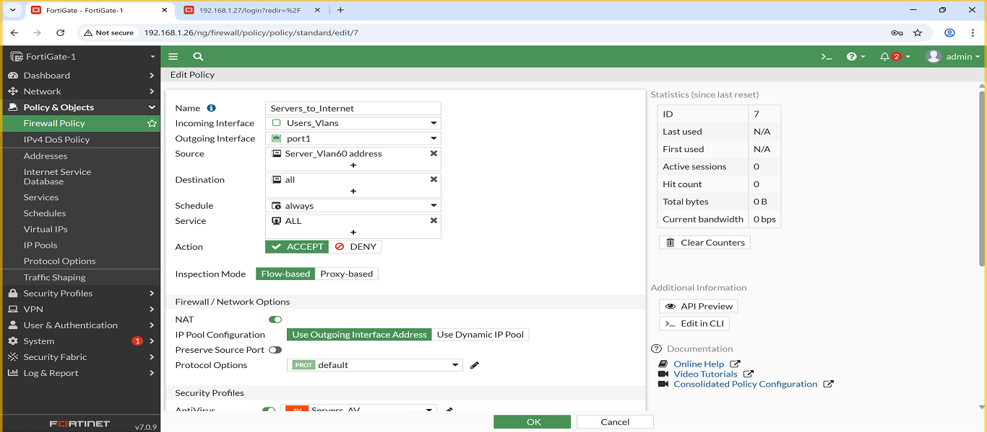
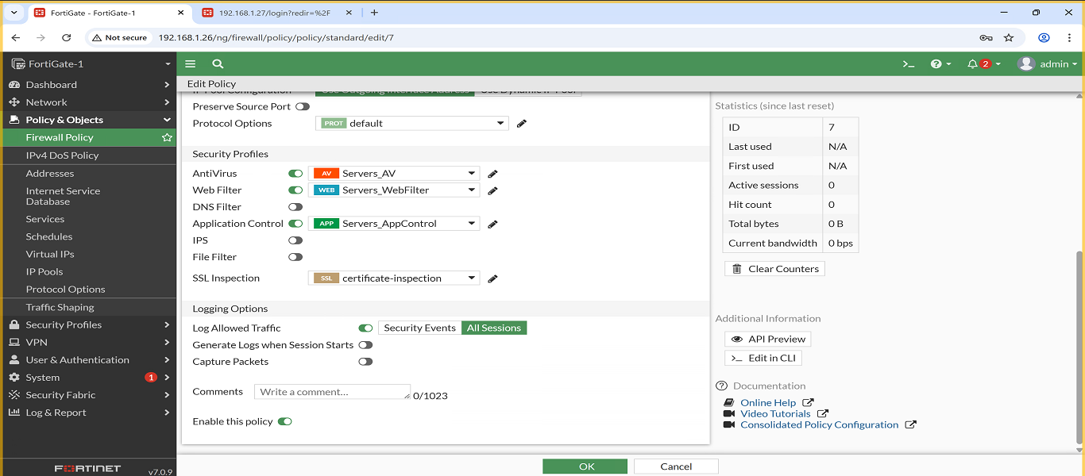
2.3 Security Profiles (HQ)

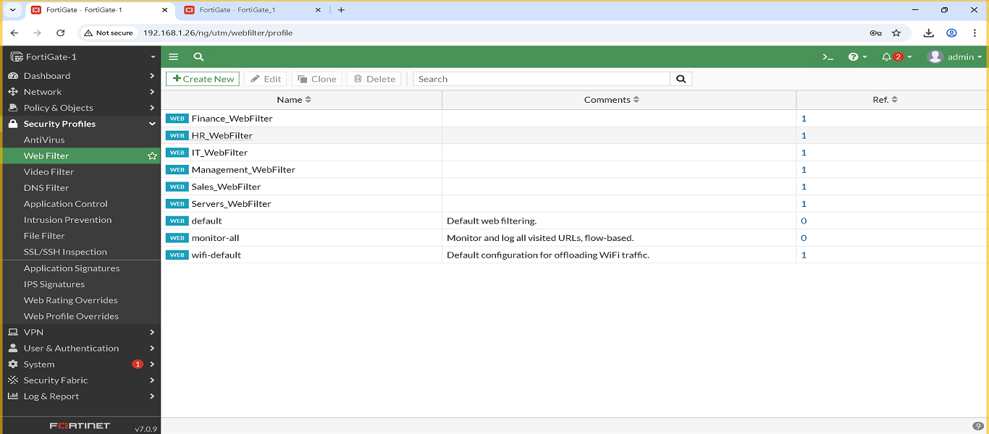
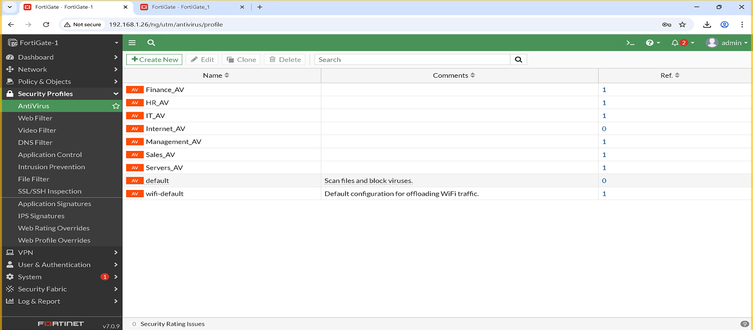
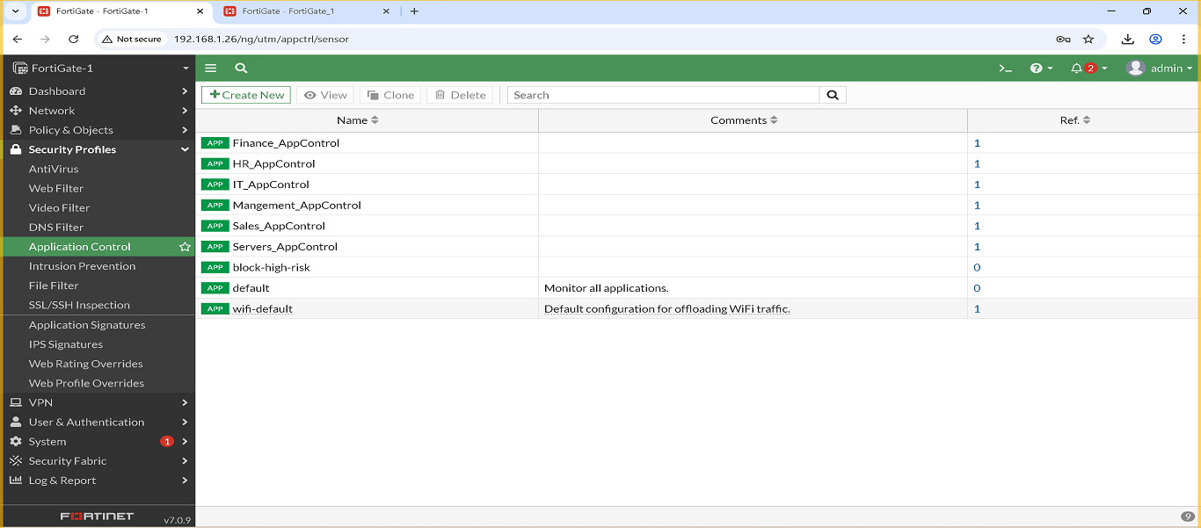
IT VLAN – Security Profiles
Three security profiles were created and assigned to the IT VLAN to enhance security and control user traffic:
- IT_WebFilter
  - Blocks: malware, phishing, hacking, gambling, proxies
  - Screenshot:
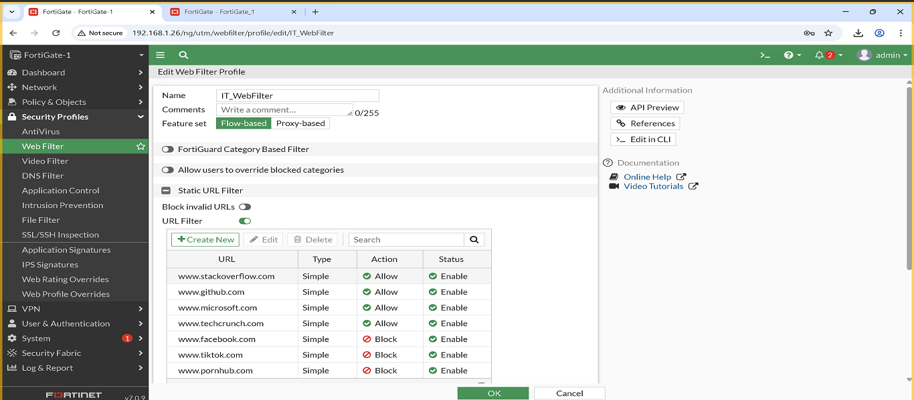
- IT_Antivirus
  - Full scan, quarantine, HTTP/SMTP/FTP scanning
  - Screenshot:
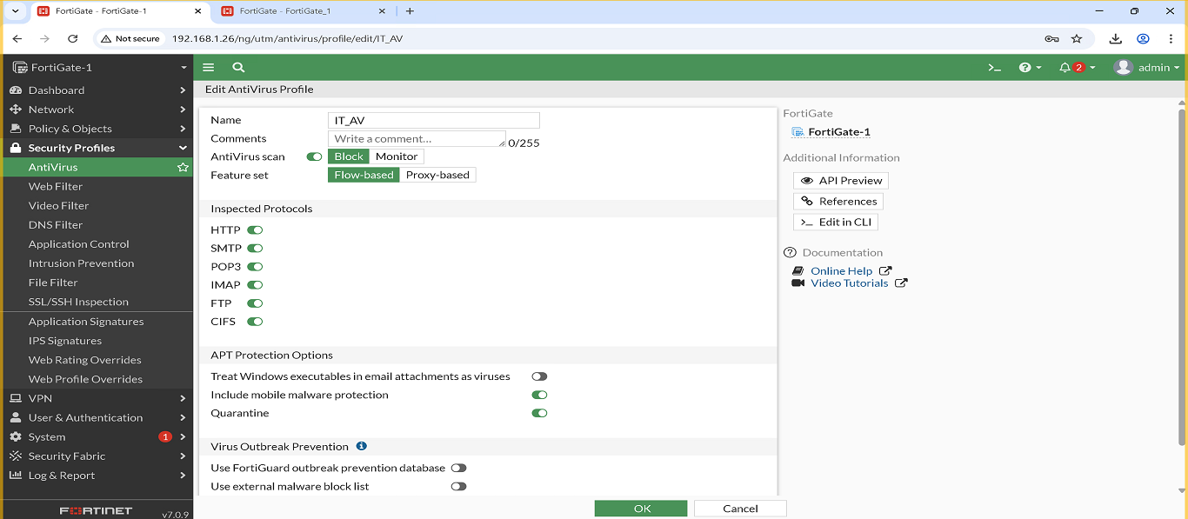
- IT_AppControl
  - Blocks: torrents, gaming, unknown apps
  - Screenshot:

HR VLAN – Security Profiles
Three profiles were applied to ensure HR browsing is monitored and controlled:
- HR_WebFilter
  - Blocks: social media, streaming, job search
  - Screenshot:
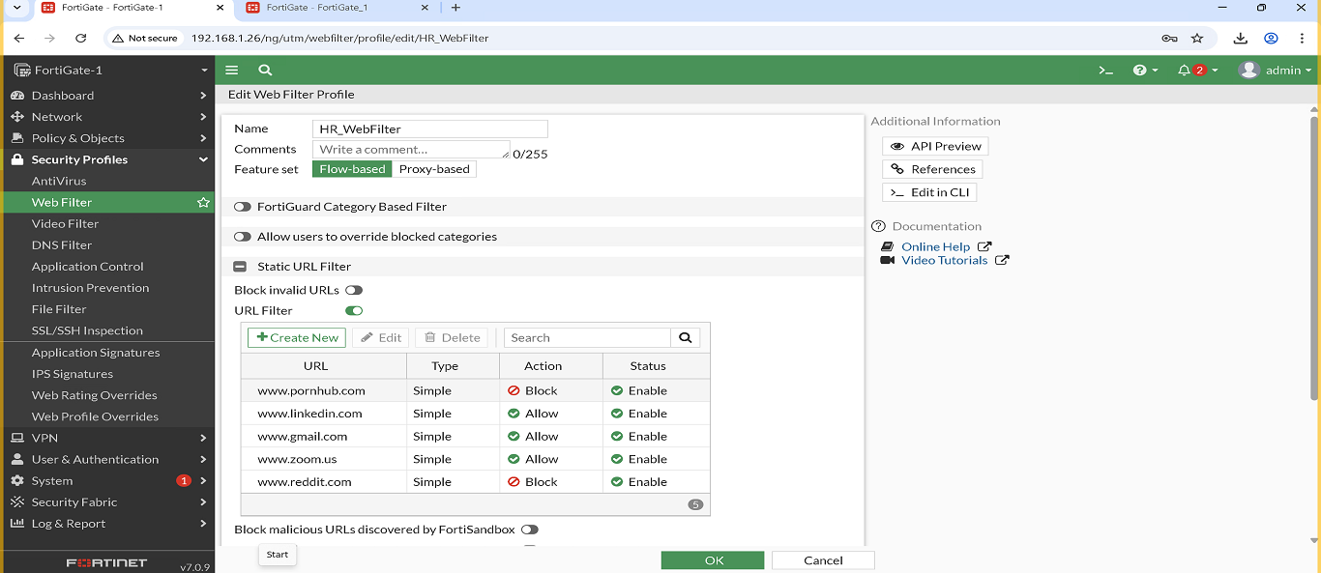
- HR_Antivirus
  - Full scan + malware protection
  - Screenshot:
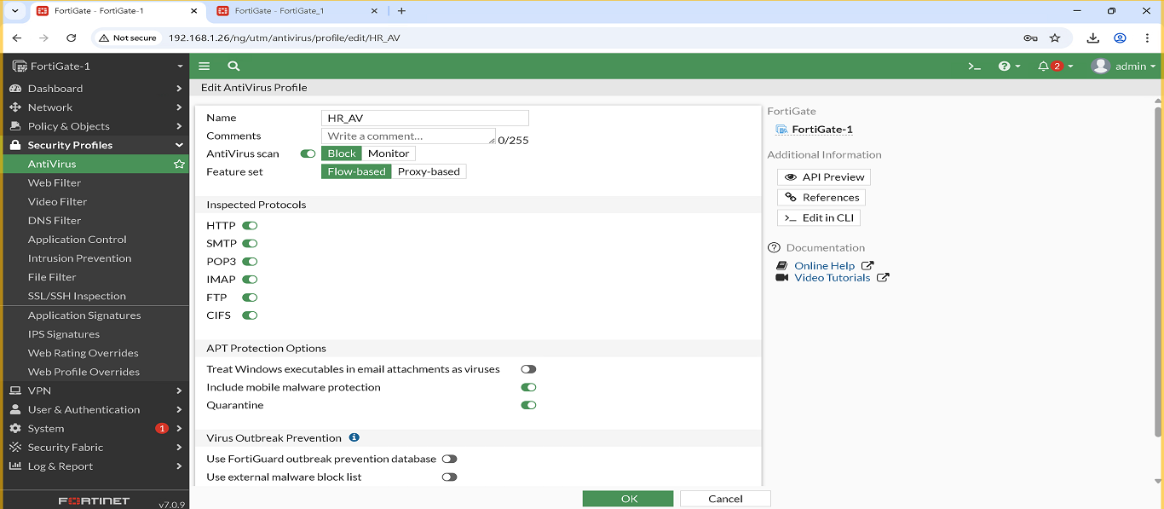
- HR_AppControl
  - Blocks: social apps, entertainment apps
  - Screenshot: (Insert here)

Finance VLAN – Security Profiles
- Finance_WebFilter
  - Blocks: crypto, fraud, hacking websites
  - Screenshot:
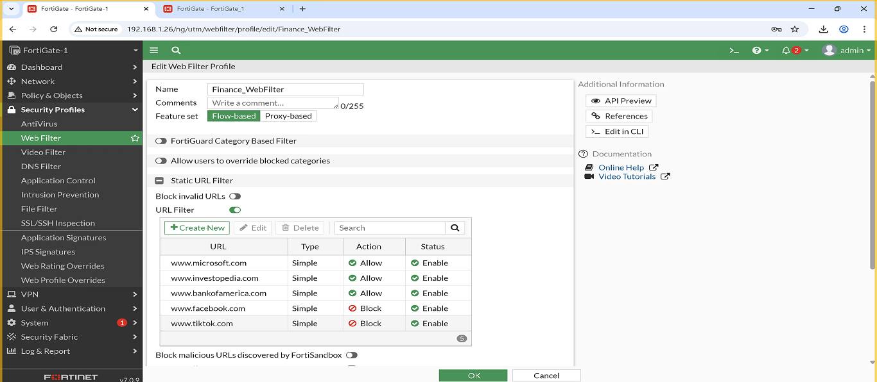
- Finance_Antivirus
  - Full scan + quarantine
  - Screenshot:
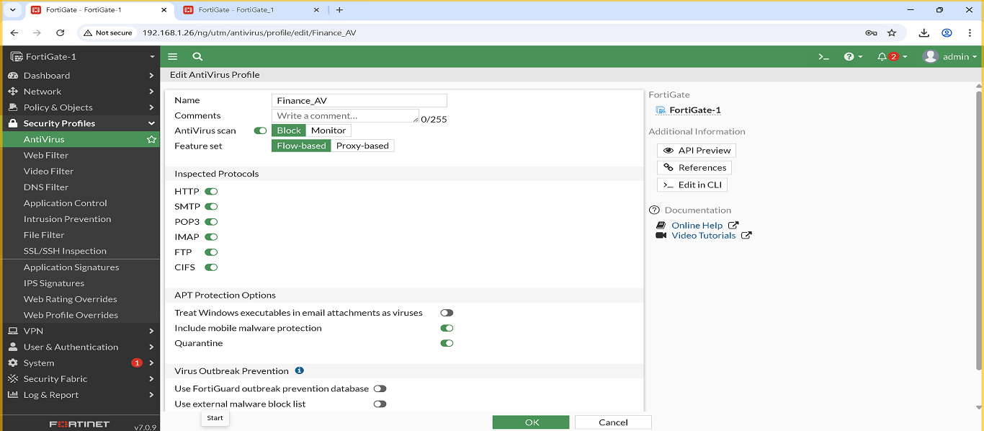
- Finance_AppControl
  - Blocks: crypto apps, P2P, high-risk apps
  - Screenshot: (Insert here)

Sales VLAN – Security Profiles
Three security profiles were created and applied to the Sales VLAN to ensure controlled and secure web access:
- Sales_WebFilter
  - Blocks: social media, streaming, entertainment, ads
  - Allows: business & cloud services
  - Screenshot:
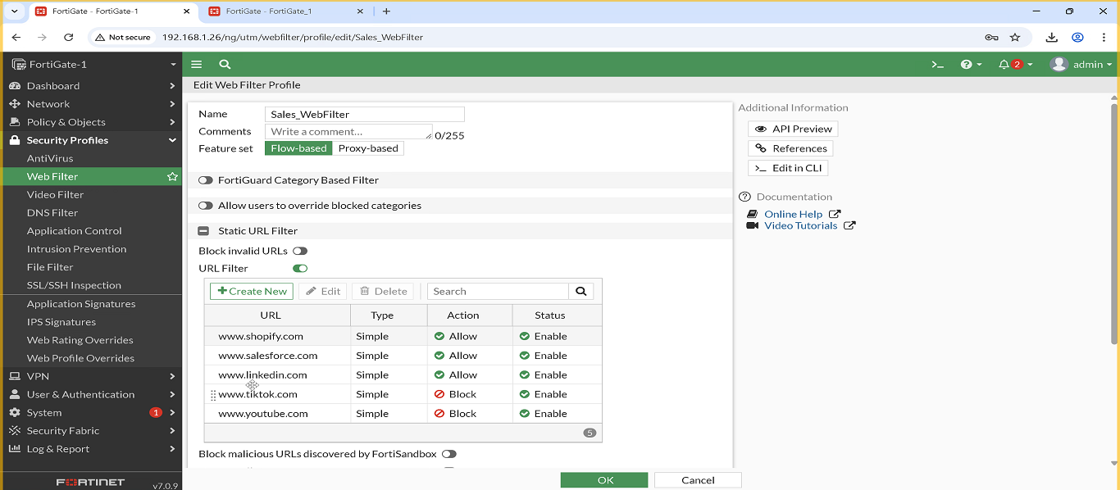
2. Sales_Antivirus
  - Full scan enabled
  - Quarantine malicious files
  - Scans: HTTP / SMTP / FTP
  - Screenshot:
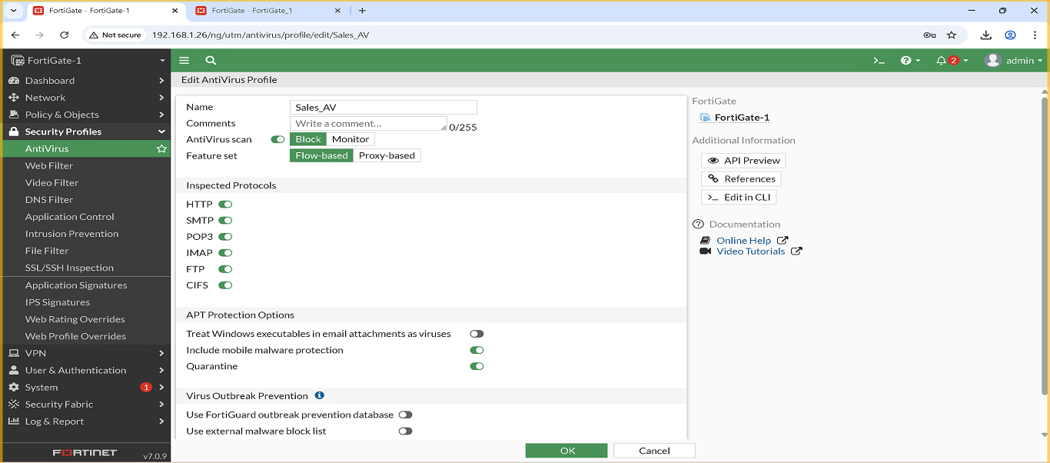
- Sales_AppControl
  - Blocks: gaming, torrent, unknown applications
  - Monitors: business apps & communication tools
  - Screenshot: (Insert here)

Management VLAN – Security Profiles
Three high-level security profiles were configured for the Management VLAN to ensure safe and controlled access:
- Management_WebFilter
  - Blocks: malicious websites, phishing, proxies
  - Allows: admin portals, business tools
  - Screenshot:
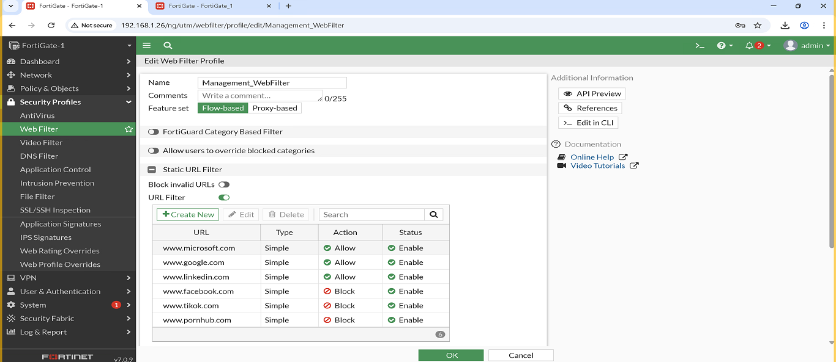
- Management_Antivirus
  - Full malware scan
  - Quarantine enabled
  - Scans file transfers & web traffic
  - Screenshot:
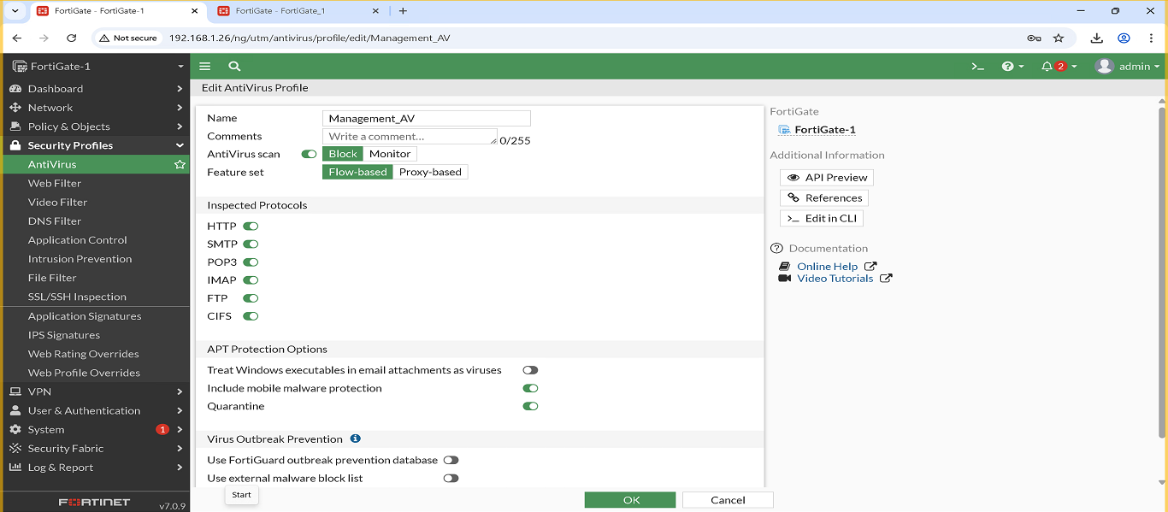
- Management_AppControl
  - Blocks: entertainment, gaming, P2P
  - Allows: administrative and productivity tools
  - Screenshot: (Insert here)

Servers VLAN – Security Profiles
Three security profiles were applied to the Servers VLAN to protect server traffic and maintain stable operations:
- Servers_WebFilter
  - Blocks: malware, phishing, hacking categories
  - Allows: required update servers (Microsoft, Linux, cloud)
  - Screenshot:
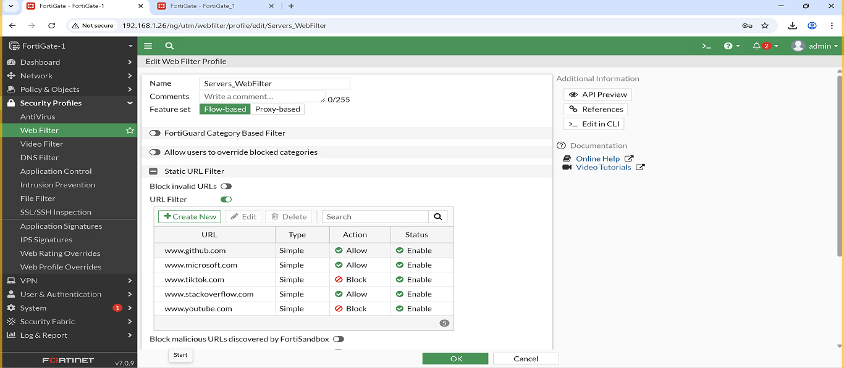
- Servers_Antivirus
  - Full scan + quarantine
  - Scans server traffic for threats (HTTP/FTP/SMTP if applicable)
  - Screenshot:
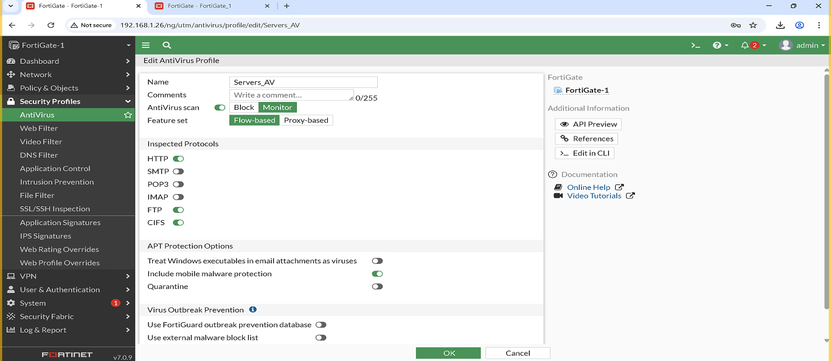
- Servers_AppControl
  - Blocks: unnecessary or risky traffic (P2P, gaming, unknown apps)
  - Allows: server-related services only
  - Screenshot: (Insert here)

3. FortiGate 2 — Branch (BR) Configuration
3.1 VLANs (BR)
Same VLAN structure as HQ:
- IT – VLAN 10 – 192.168.10.0/24
- HR – VLAN 20 – 192.168.20.0/24
- Finance – VLAN 30 – 192.168.30.0/24
- Management – VLAN 40 – 192.168.40.0/24
- Sales – VLAN 50 – 192.168.50.0/24
- Servers – VLAN 60 – 192.168.60.0/24
3.2 Firewall Policies (BR)
Firewall Policies Implemented
The following firewall policies were created and configured on this FortiGate device.
Each policy includes a screenshot for reference, showing the exact configuration applied on the firewall.
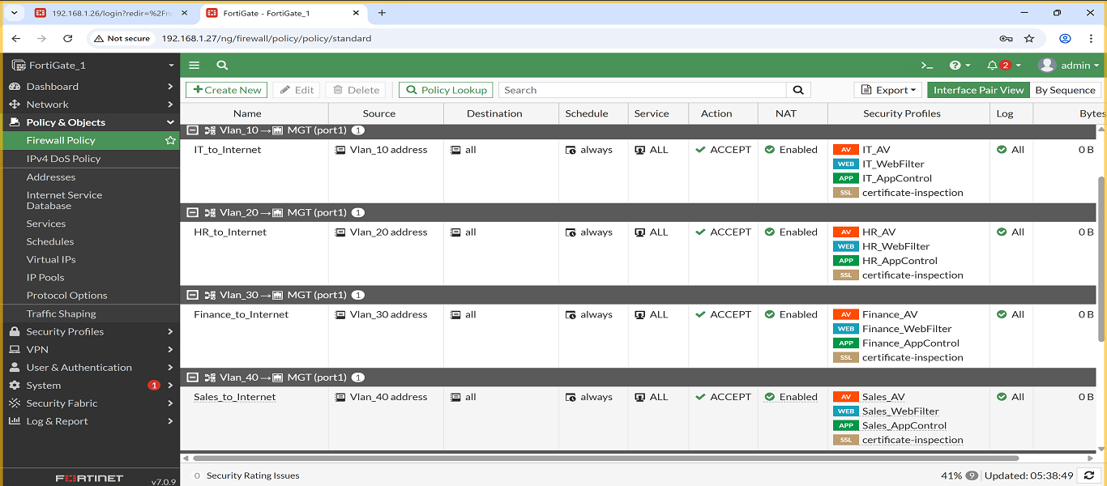
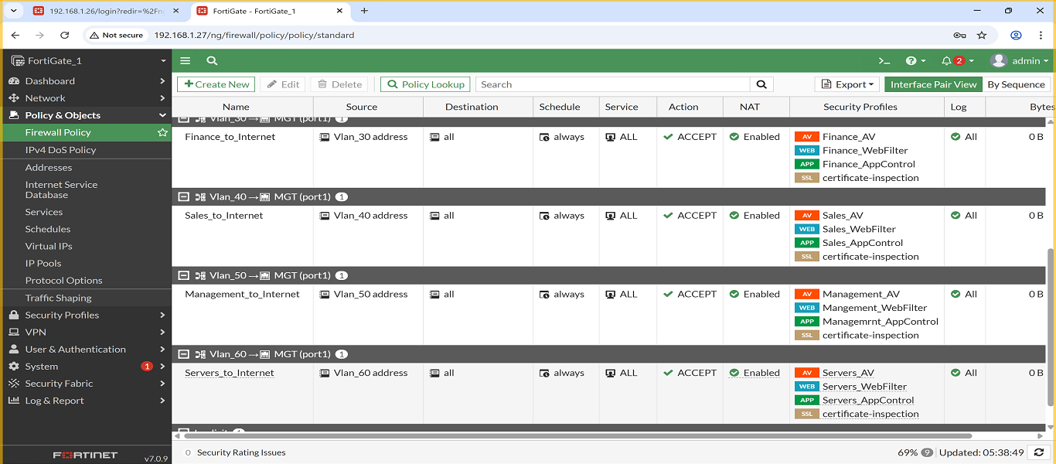
1. Policy: IT → Internet
- Description: Allows IT VLAN access to the internet, and applies the following security profiles: Web Filter, Antivirus, Application Control, and IPS.
- Screenshot:
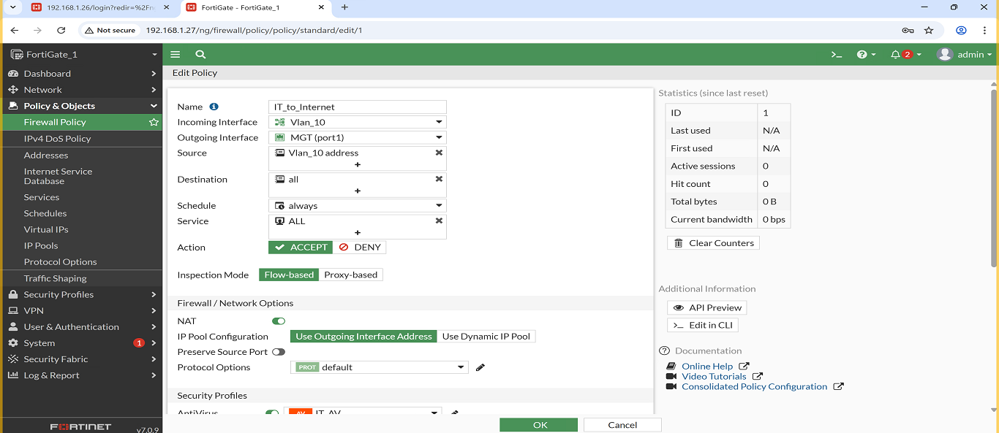
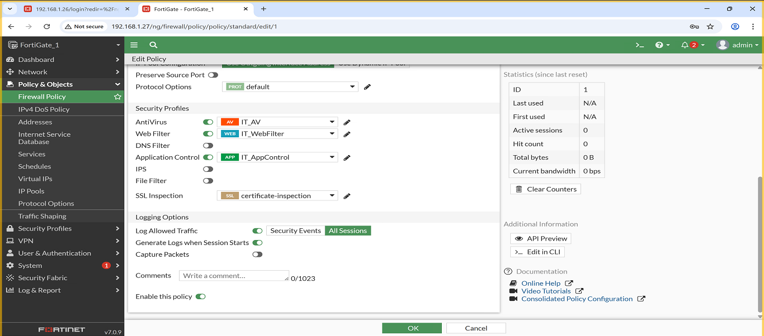

2. Policy: HR → Internet
- Description: Allows HR VLAN access to the internet, and applies the following security profiles: Web Filter, Antivirus and Application Control.
- Screenshot:
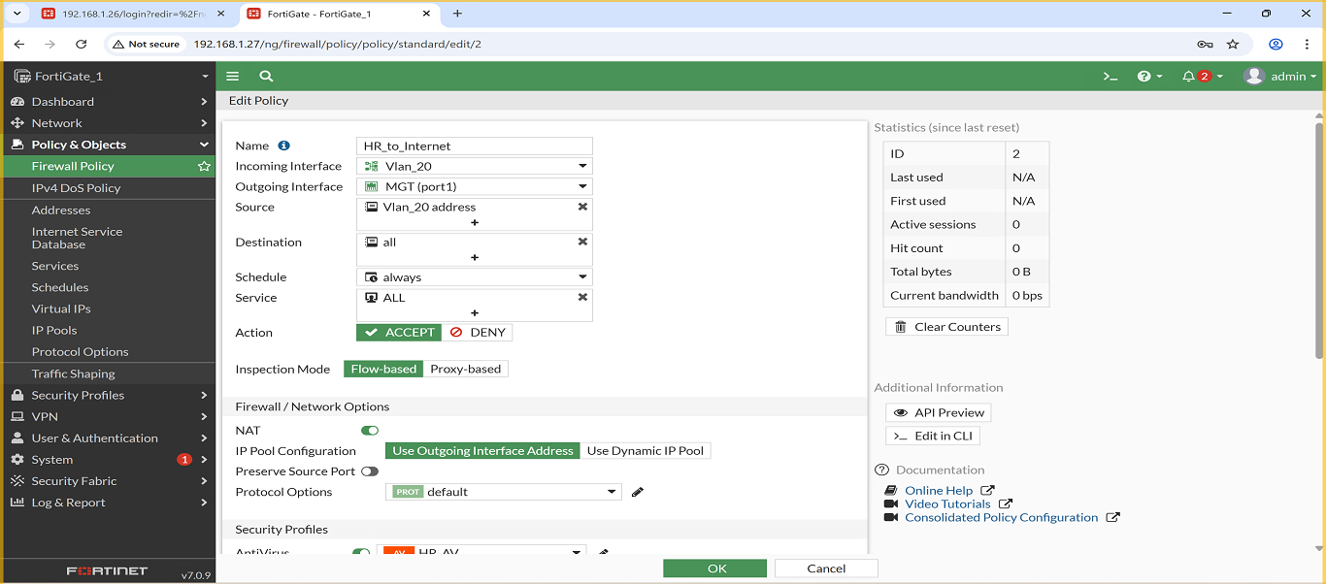
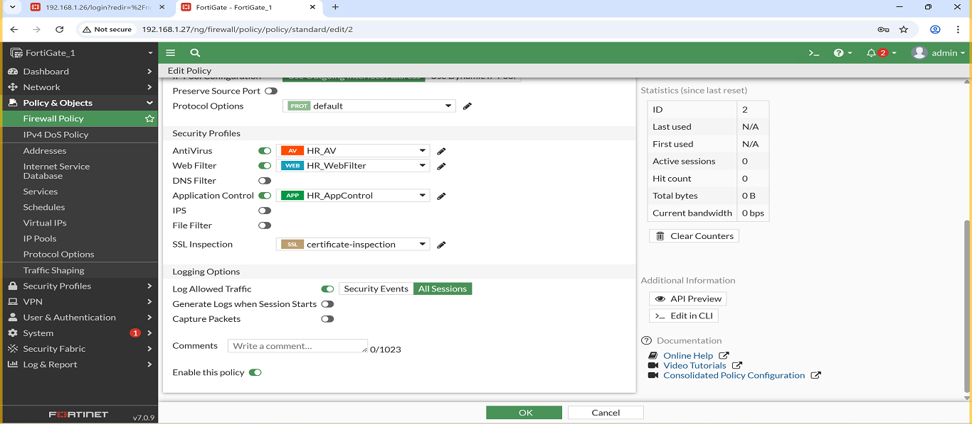

3. Policy: Finance → Internet
Description: Allows Finance VLAN access to the internet, and applies the following security profiles: Web Filter, Antivirus and Application Control.
- Screenshot:
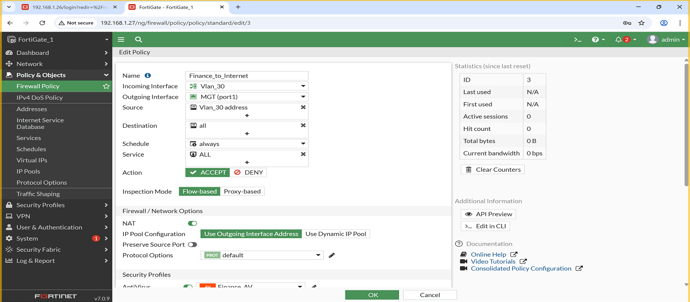
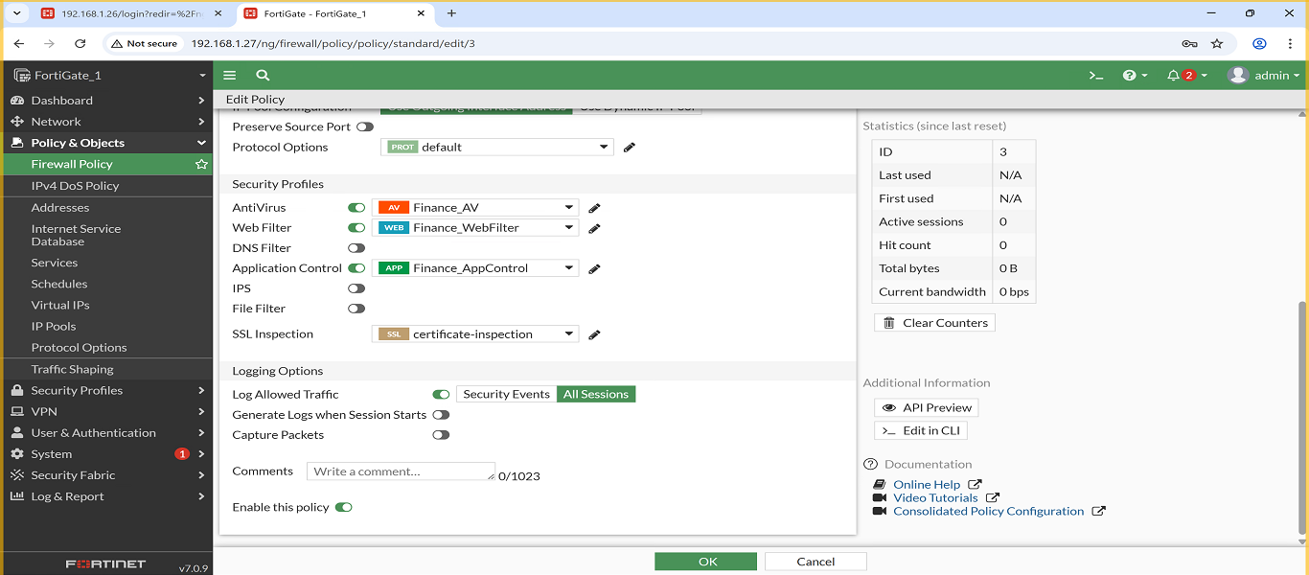

4. Policy: Management → Internet
- Description: Allows Management VLAN access to the internet, and applies the following security profiles: Web Filter, Antivirus and Application Control.
- Screenshot:
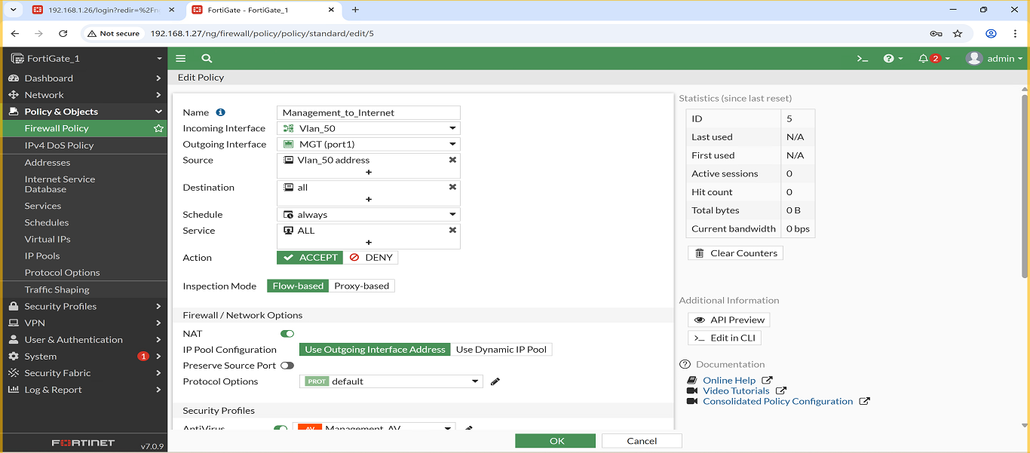
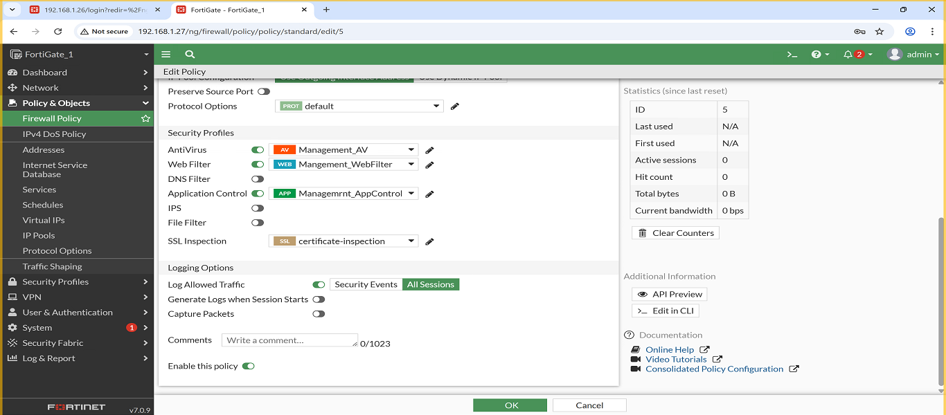
5. Policy: Sales → Internet
- Description: Allows Sales VLAN access to the internet, and applies the following security profiles: Web Filter, Antivirus and Application Control.
- Screenshot:
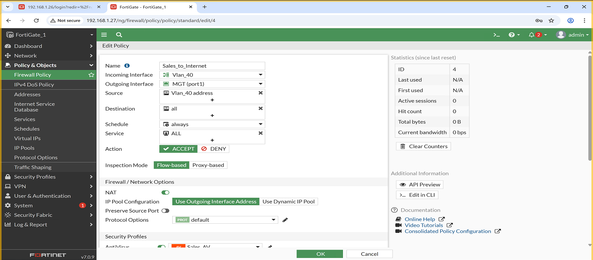
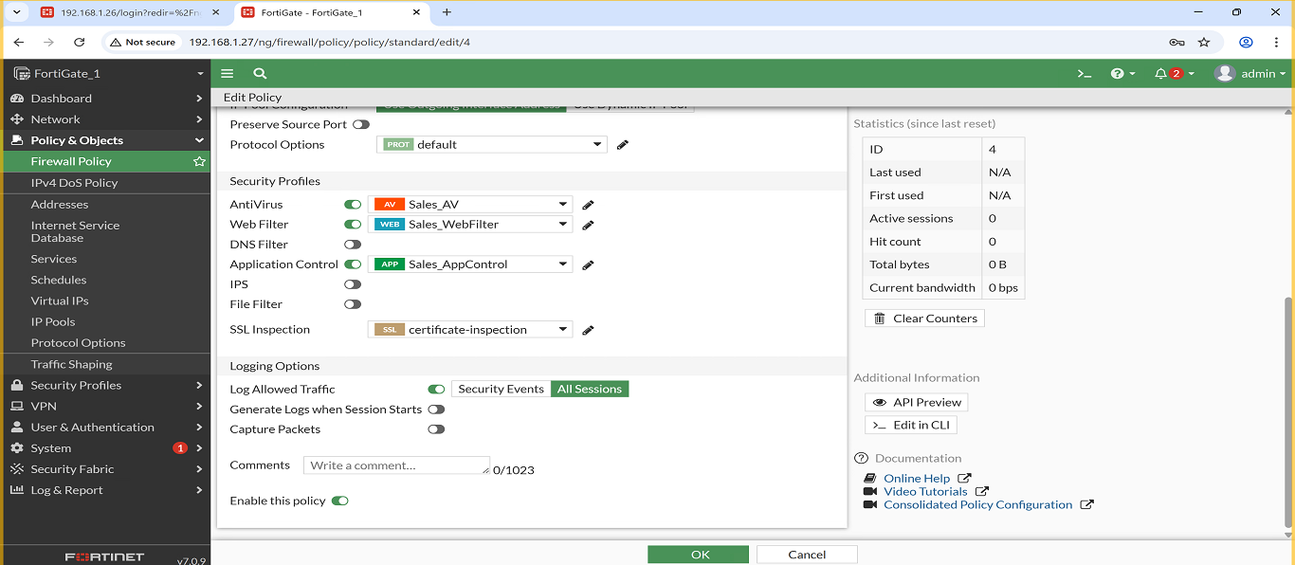
6. Policy: Servers → Internet
- Description: Allows Servers VLAN access to the internet, and applies the following security profiles: Web Filter, Antivirus and Application Control.
- Screenshot:
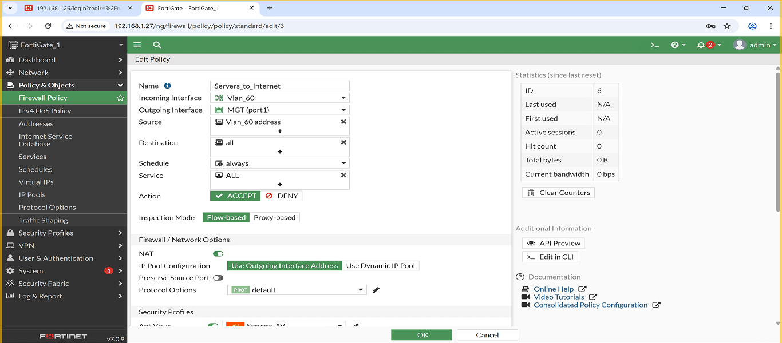
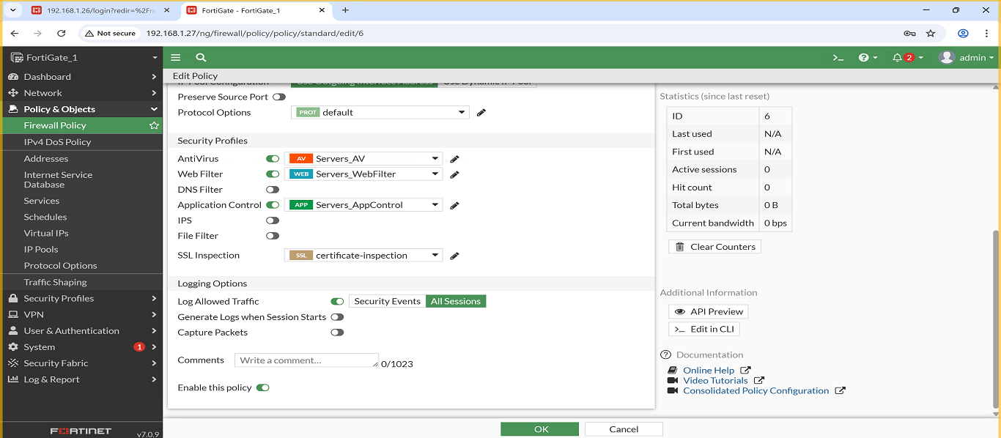
3.3 Security Profiles (BR)

IT VLAN – Security Profiles
Three security profiles were created and assigned to the IT VLAN to enhance security and control user traffic:
- IT_WebFilter
  - Blocks: malware, phishing, hacking, gambling, proxies
  - Screenshot: 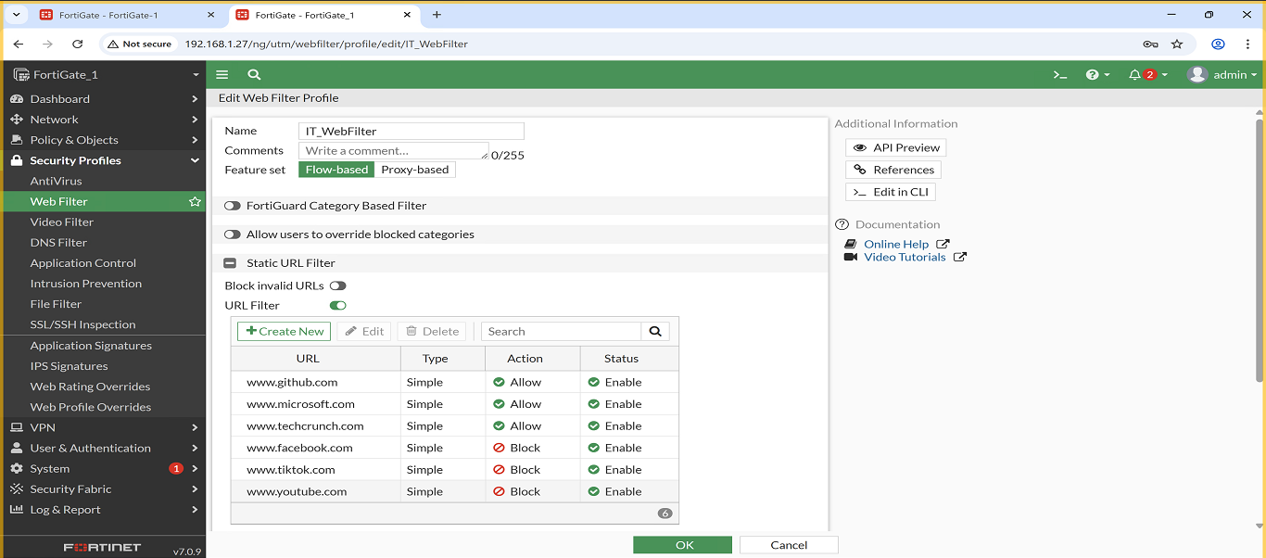

  - IT_Antivirus
  - Full scan, quarantine, HTTP/SMTP/FTP scanning
  - Screenshot:
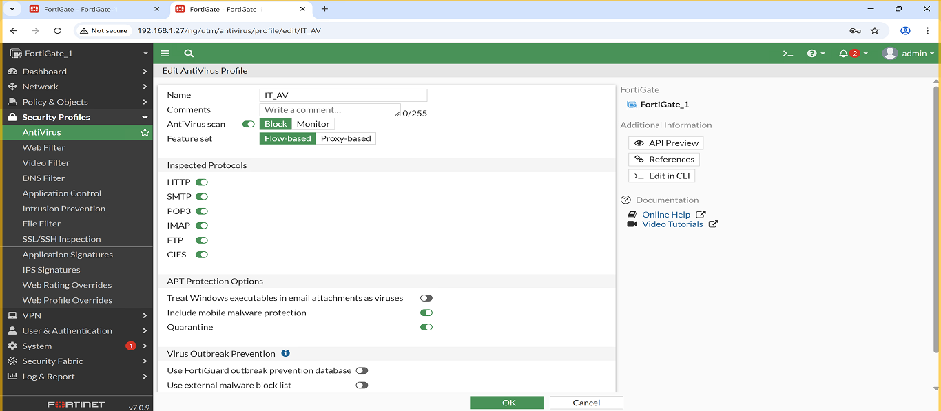
- IT_AppControl
  - Blocks: torrents, gaming, unknown apps
  - Screenshot: (Insert here)

HR VLAN – Security Profiles
Three profiles were applied to ensure HR browsing is monitored and controlled:
- HR_WebFilter
  - Blocks: social media, streaming, job search
  - Screenshot:
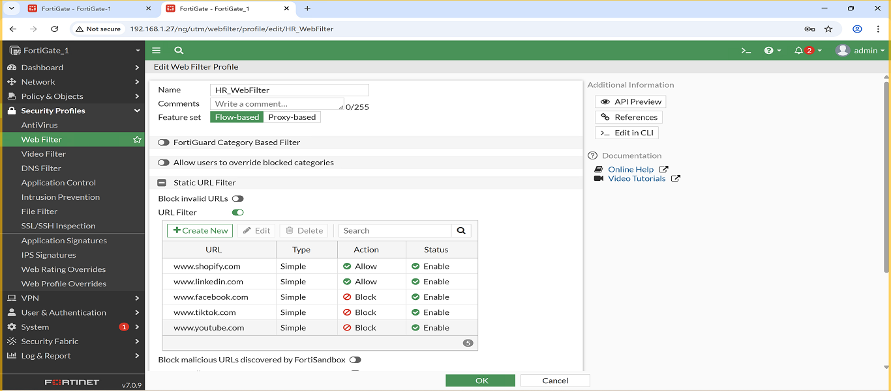
- HR_Antivirus
  - Full scan + malware protection
  - Screenshot:
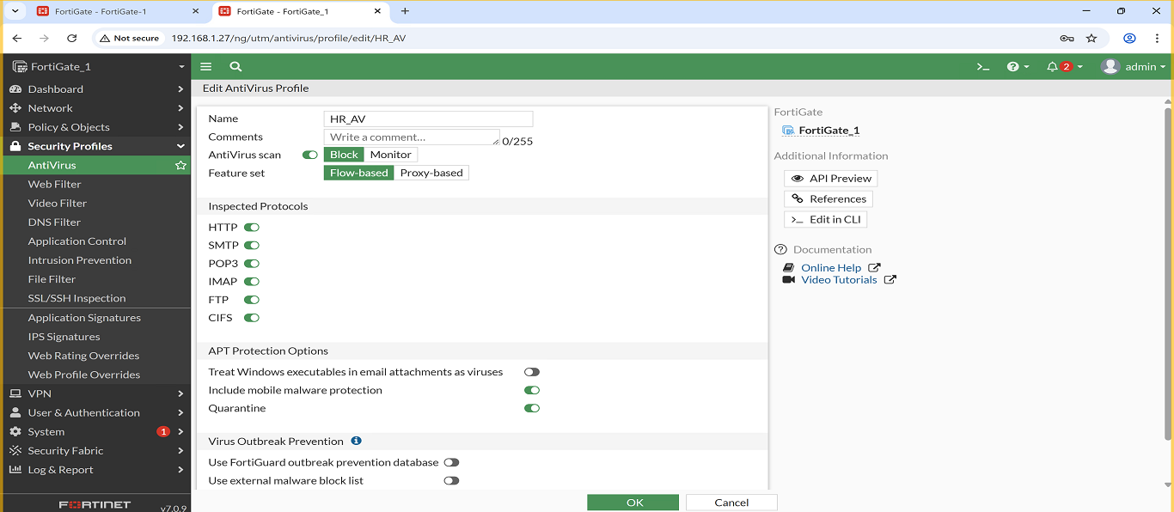
- HR_AppControl
  - Blocks: social apps, entertainment apps
  - Screenshot: (Insert here)

Finance VLAN – Security Profiles
- Finance_WebFilter
  - Blocks: crypto, fraud, hacking websites
  - Screenshot:
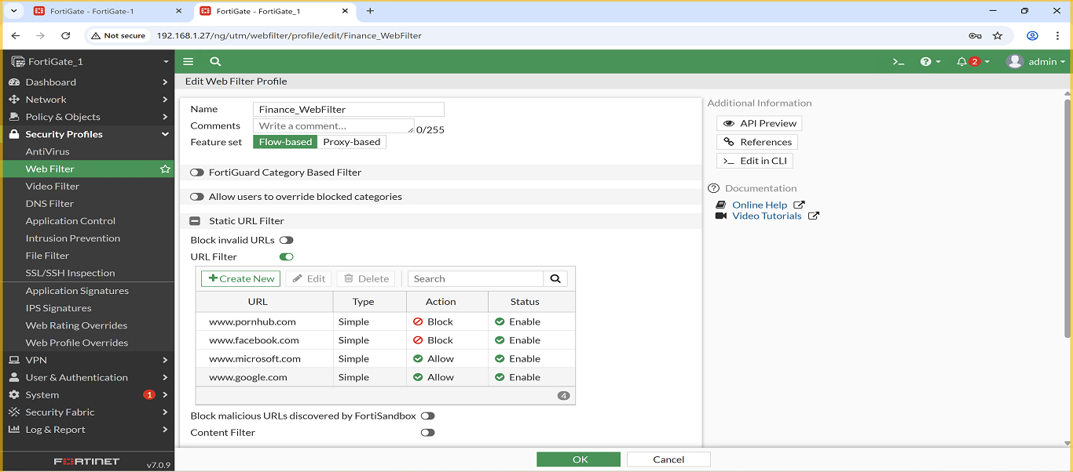
- Finance_Antivirus
  - Full scan + quarantine
  - Screenshot:
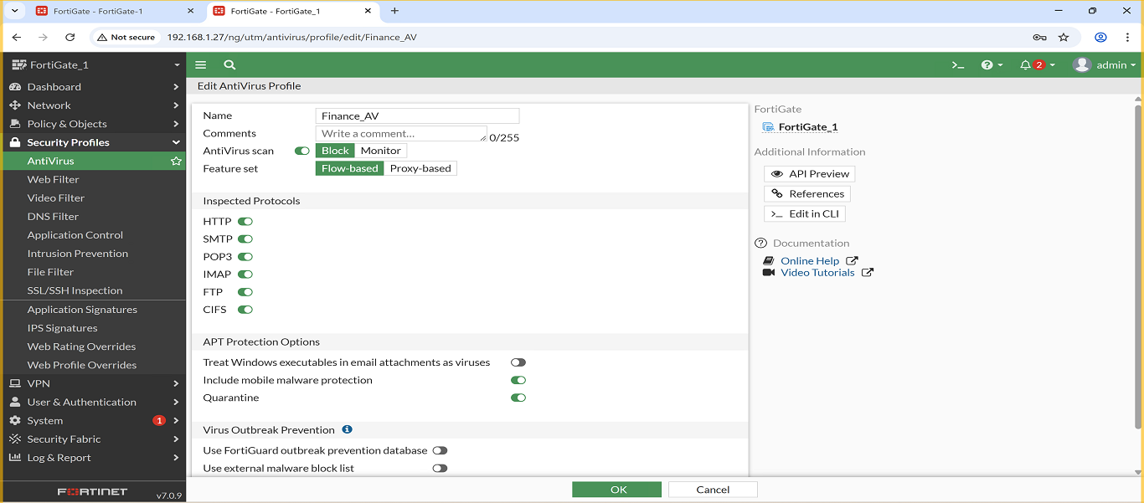
- Finance_AppControl
  - Blocks: crypto apps, P2P, high-risk apps
  - Screenshot: (Insert here)

Sales VLAN – Security Profiles
Three security profiles were created and applied to the Sales VLAN to ensure controlled and secure web access:
- Sales_WebFilter
  - Blocks: social media, streaming, entertainment, ads
  - Allows: business & cloud services
  - Screenshot:
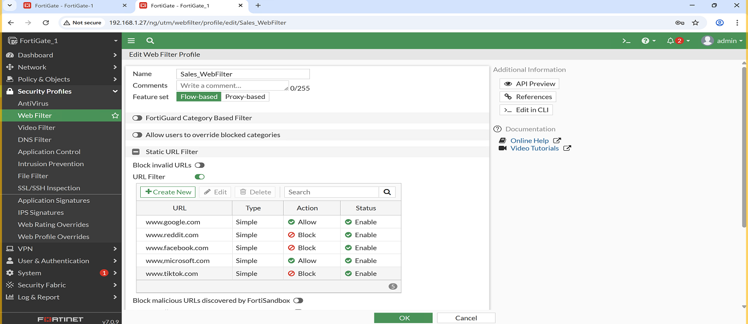
- Sales_Antivirus
  - Full scan enabled
  - Quarantine malicious files
  - Scans: HTTP / SMTP / FTP
  - Screenshot:
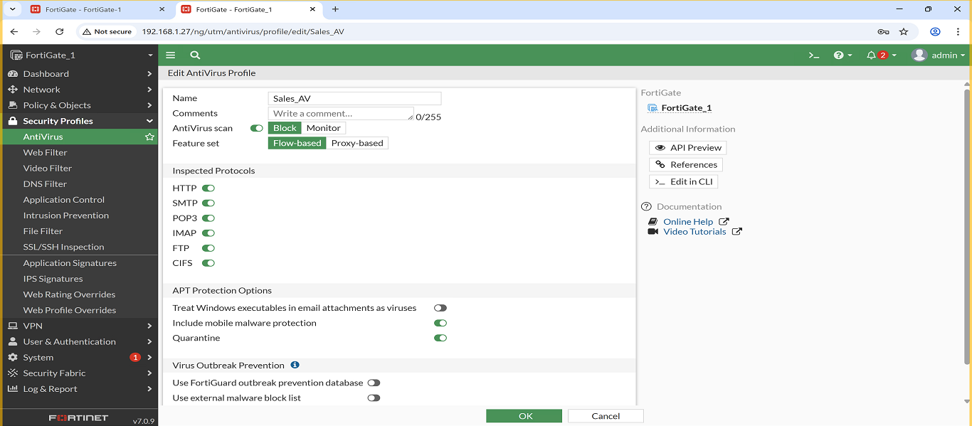
- Sales_AppControl
  - Blocks: gaming, torrent, unknown applications
  - Monitors: business apps & communication tools
  - Screenshot: (Insert here)

Management VLAN – Security Profiles
Three high-level security profiles were configured for the Management VLAN to ensure safe and controlled access:
- Management_WebFilter
  - Blocks: malicious websites, phishing, proxies
  - Allows: admin portals, business tools
  - Screenshot:
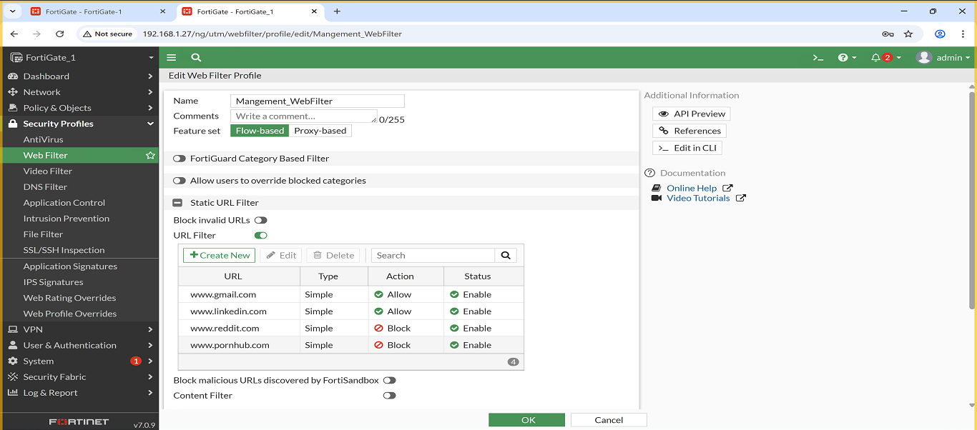
- Management_Antivirus
  - Full malware scan
  - Quarantine enabled
  - Scans file transfers & web traffic
  - Screenshot:
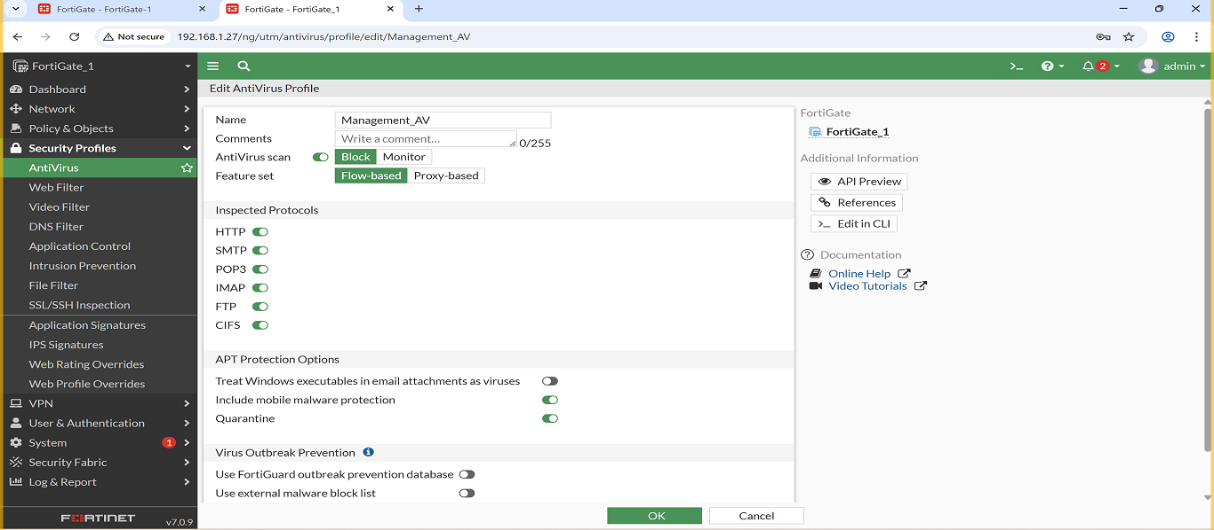
- Management_AppControl
  - Blocks: entertainment, gaming, P2P
  - Allows: administrative and productivity tools
  - Screenshot: (Insert here)

Servers VLAN – Security Profiles
Three security profiles were applied to the Servers VLAN to protect server traffic and maintain stable operations:
- Servers_WebFilter
  - Blocks: malware, phishing, hacking categories
  - Allows: required update servers (Microsoft, Linux, cloud)
  - Screenshot:
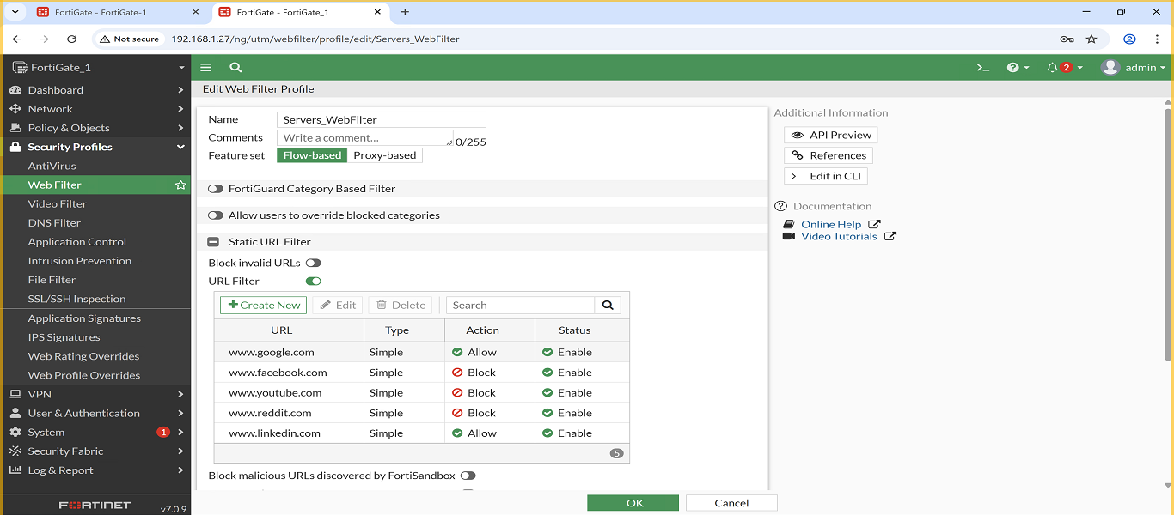
- Servers_Antivirus
  - Full scan + quarantine
  - Scans server traffic for threats (HTTP/FTP/SMTP if applicable)
  - Screenshot:
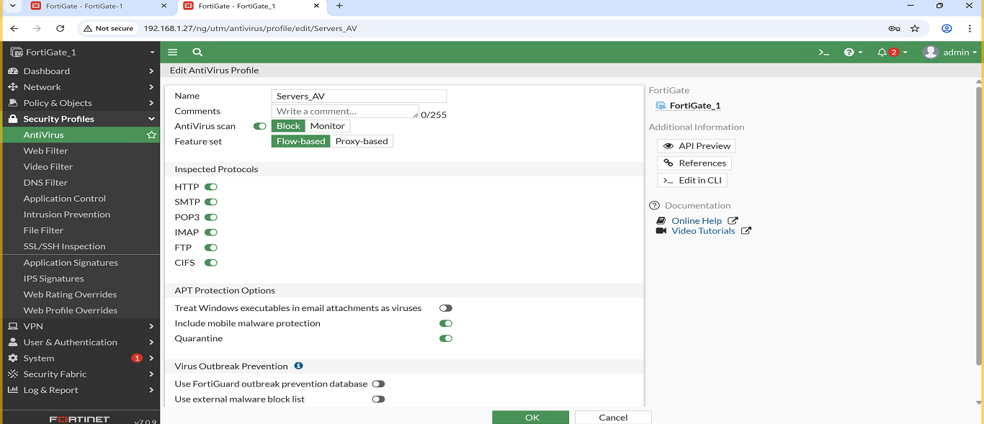
- Servers_AppControl
  - Blocks: unnecessary or risky traffic (P2P, gaming, unknown apps)
  - Allows: server-related services only
  - Screenshot:

